S.N | NAME OF THE STAFF | FATHER’S / HUSBAND NAME | Address | CAT. | QUALIFICATION | Percentage | PHOTOGRAPH | Contact No/Mobile No. | DATE OF JOINING | BANK A/c No. | DETAILS OF SALARY | REMARKS
1 | Dr.shyam narain kumar | Late ramchandra kumar | Darbhanga | Gen | Ph.D |  | 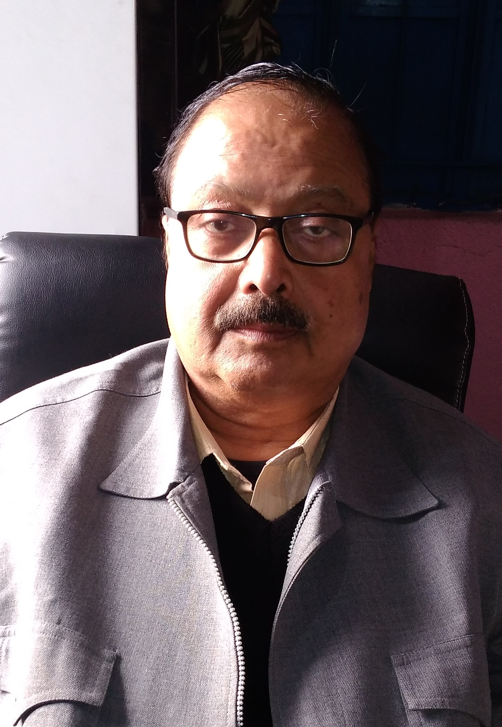 | 9431084843 | 07.01.2017 | 6913000100035355 | 50001 | awarded
2 | Kumari manju pathak | Sangeet jha | Darbhanga | Gen | M.ED | 68% |  | 9534413866 | 14.10.2016 | 6913000100070555 | 21600
3 | Avinash kumar | Tun tun jha | Darbhanga | Gen | M.ED | 56% | 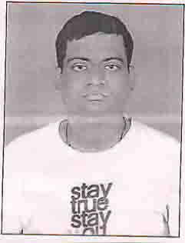 | 9852688369 | 14.10.2016 | 0108020100013835 | 21600
4 | Shambhu ram | Hari mochi | Darbhanga | SC | M.A (EDU) | 65% |  | 8294328621 | 14.10.2016 | 6913000100070500 | 21600
5 | Pooja sharma | Ashok kumar thakur | Darbhanga | OBC | MCA | 62% |  | 8434800753 | 14.10.2016 | 6913000100071891 | 21600
6 | Anand kumar priyadarshi | Dr.dev narayan yadav | Samastipur | BC | M.ED | 64% | 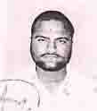 | 8409337529 | 14.10.2016 | 6913000400003765 | 21600
7 | Rani kumari | Ramprakash sahni | Samastipur | EBC | M.ED | 71% | 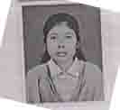 | 9939071317 | 14.10.2016 | 0198001500033767 | 21600
8 | Nagesh kumar jha | Sundar jha | Darbhanga | Gen | M.A (EDU) | 65% |  | 9934069604 | 14.10.2016 | 11369671650 | 21600
9 | Durga rani sikdar | Late sudhir ranjan sikdar | Darbhanga | ST | M.ED | 72% |  | 8935985363 | 14.10.2016 | 69130004000018 | 21600
10 | Nagendra kumar jha | Uday chandra jha | Darbhanga | Gen | M.ED | 60% |  | 9999751476 | 14.10.2016 | 448402010091516 | 21600
11 | Satish kumar sahi | Surya nath sahi | UP | Gen | M.ED | 65% |  | 9458626530 | 14.10.2016 | 0570000400116264 | 21600
12 | Raghvendra jha | Shyam chandra jha | Darbhanga | Gen | M.A (EDU) | 72% |  | 9308452454 | 14.10.2016 | 20080432765 | 21600
13 | Ruby Kumari | Jitan raja | Darbhanga | SC | M.A (ECO) | 66% |  | 9006496194 | 14.10.2016 | 17750100702167 | 21600
14 | Arvind kumar yadav | Tejendra yadav | Darbhanga | OBC | M.Ped | 53% |  | 9576188794 | 14.10.2016 | 6913000100025908 | 21600
15 | Kanchan kiran | Kusheshwar yadav | Madhhubani | OBC | M.ED | 62% |  | 9471644849 | 14.10.2016 | 20386262468 | 21600
16 | Tarikur rahman | Md.obaidur rahman | Darbhanga |  | M.ED | 60% |  | 9431095652 | 14.10.2016 | 162810100025592 | 21600

